Bridging Social Distances in the Changing Classroom

Title: 18 pt Arial bold

Andrew Reimann

Aoyama Gakuin University

Name & affiliation: 16 pt Arial

Andrew Reimann co-coordinates the AGU English Department’s IEP. Previously, he was an associate professor at Utsunomiya and Tokai universities. His Ph.D. is in Applied Linguistics focusing on Intercultural communication and materials design, He teaches classes on Comparative Culture and Intercultural Communication. His research interests include raising cultural awareness and communication strategies.

Abstract: 12 pt Arial / block indentation

This paper summarizes the author’s contribution to the LLL SIG-sponsored forum “Bridging Social Distances in Online Learning” that was presented at the JALT 2020 Online Conference, co-presented with Joseph Dias, Catherine Takasugi, Jonathon Campbell, Natsuki Suzuki, Fraser Gould, and Kazuko Namba.

# Introduction and Rationale

Main section headings: 16 pt Arial bold

Main text of paper 16 pt Arial

Don't indent 1st paragraph; indent from 2nd

The move to online learning has created both new challenges and opportunities for teachers and students alike. The possibility of conducting classes from anywhere and across multiple platforms has resulted in freedom and flexibility as well as bringing new resources into the virtual classroom that would be otherwise difficult to reproduce in the traditional classroom (Chiu, Lin, & Lonka, 2021). Through platforms like Zoom, the ability to easily invite international guest speakers from anywhere in the world is suddenly feasible.

Students who might miss classes due to late trains, job interviews or personal reasons are likewise able to join from virtually anywhere. Assignments, feedback and grades can similarly be submitted or returned easily without time or geographical limitations.

One of the more serious casualties of online learning, however is the loss of the personal connection of the face to face classroom. This has a profound impact on the nature and quality of discussion and active participation in interactive presentations or communication classes.

A way to effectively counter the decline in personal connections required for meaningful discussions is to create specialized discussion templates and virtual worksheets which students can prepare and share beforehand, thereby boosting confidence, efficiency and overall quality. The following will describe how Google slides can be used to create a diverse range of

interactive materials that can be distributed, accessed and read across multiple formats and platforms including MS Office, PDF, Text or graphic interfaces.

# Creation and Formatting

Main section headings: 16 pt Arial bold

Google slides is a free and easy to use program for creating presentations similar to MS PowerPoint or Apple Keynote. It is also a versatile platform for creating other types of materials as it is essentially a powerful blank slate with a comprehensive arsenal of built-in tools. The nature of the open-source format allows it to be highly transferrable, accessible, and compatible to most devices and programs. Students can also access, download, create and submit files, assignments, reports or presentations from any device, greatly improving participation and quality of work. Three activities using Google slide templates will be described. These include visual vocabulary journals, media discussion summaries, and theme based mini presentations.

The process for creating theses materials is the same and only the format or layout is different depending on topic, goals or activity. After opening a new file in Google slides, design a template of the type of assignment you wish to make (see examples below). Once this is completed save as a jpeg file and reinsert the image into the slide. From here insert text you wish the students to edit and save as a regular Google slide. In this way students can complete the assignment without changing the format of the document.

# Distribution and Access

Once created, these files can then be distributed via email link through any type of LMS, Google Classroom, Google Drive or by sending the actual file. Students can then access these, complete and return them either by clicking submit in Google classroom or saving in an alternative format such as PowerPoint or PDF and sending them back via email, text or LMS. Once received instructors can save, consolidate or redistribute assignments in accessible folders or as a single PDF file that all students can view or download. This helps them prepare for class, engage with content and become more familiar with the topics and materials.

# Application in The Classroom

Sub section headings: 16 pt Arial bold italic

Label all graphics clearly.

Giving all students the ability to access each other’s files before class greatly improves participation and the quality of discussion and comprehension of topics and contents. Students are able to read ahead, conduct further research, develop their opinions and respond to questions. Apart from making procedures and preparation more efficient this further provides familiarization with materials while also building rapport, confidence and motivation. The following will describe how the 3 templates are used.

## Template 1: Visual Vocabulary Board

This vocabulary building activity allows students to creatively and comprehensively explore and engage with key concepts. Each student is free to choose one key word that they find interesting, important or challenging. They then provide a definition, translation, example sentence and a representative image. These templates can be consolidated into one PDF or shared as mini presentations. These diverse ways of communicating the same concept creates a deeper understanding and ownership of the vocabulary that benefits all students. Finally, students can download all of the files and keep them as a record or glossary of relevant terms or as a visual vocabulary list.

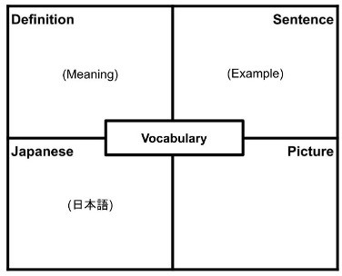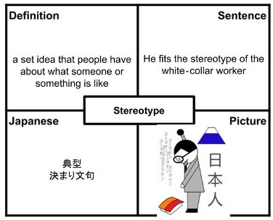

***Template 1: Visual Vocabulary Board (only the text in parentheses can be modified).***

## Template 2: Media Discussion Summary

Being able to interact and meaningfully engage in discussions is a basic challenge of online learning. By summarizing research and materials, providing links and references, explaining keywords and preparing discussion questions, all students can be ready to participate actively and with confidence. The media discussion template serves as a vehicle for students to organize and share their ideas, and develop opinions on relevant topics and themes. Summarizing important ideas from either an article or video allows students to autonomously prepare and process a diversity of information that might otherwise be inaccessible.

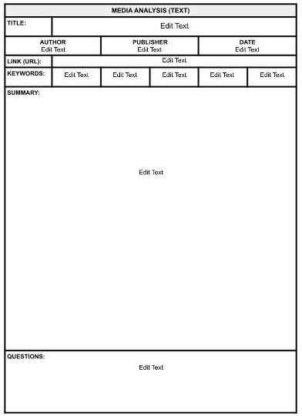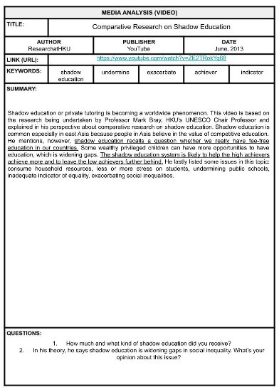

***Template 2: Media Discussion Summary***

Label all graphics clearly.

## Template 3: Thematic Mini Presentation Worksheet

Presentations in isolation is another challenge of online learning that is difficult to overcome. Unable to gauge the audience’s reaction or comprehend speakers’ meanings or intentions easily can create negative attitudes, despondency and unwillingness to engage or participate. Needles to say, this is discouraging for presenters and audiences alike.

Preparing a worksheet or template on key topics to be distributed beforehand has the effect of eliminating many of the stresses and barriers of online presentation. All students can preview materials and prepare comments, opinions or questions beforehand.

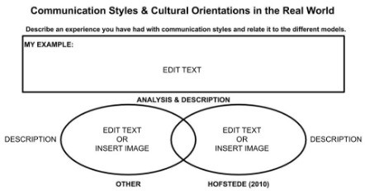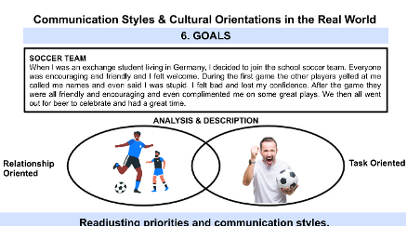

***Template 3: Thematic Mini Presentation Worksheet***

Being ready, willing and able to participate improves the overall atmosphere and reception of information that may or may not be comprehensible through the medium of online presentation alone. This reduces much of the burden and uncertainty and allows students to present with confidence and also share ideas, opinions and questions as an active and attentive audience. With these distracting influences removed, a general positive motivation is created and transferred to discussion activities involving active and attentive communication and exchange.

# Conclusion and Summary

As described in the above examples, using virtual templates and worksheets has the power to actively engage students with materials and concepts, develop motivation and improve interpersonal connections through confidence building and more

meaningful participation. The online classroom, out of necessity, has isolated many students however through the creation of inspirational and interactive materials, teachers can bring students together and bridge social distances.

References in APA style; reverse indentation

# References

Chiu, T.K.F., Lin, TJ. & Lonka, K. Motivating Online Learning: The Challenges of COVID-19 and Beyond. Asia-Pacific Education Research 30, 187–190 (2021). https://doi.org/10.1007/ s40299-021-00566-w